EARWAX Information sheet.
Earwax is a normal build-up of dead cells, hair, foreign material such as dust, and natural wax which forms a protective coating on the skin in the ear canal. The quantity of earwax produced varies greatly from person to person. A doctor or nurse can look into the ear canal and confirm a plug of earwax has formed. A plug of earwax is not a serious problem, more a nuisance. You only need to remove earwax if it is causing symptoms such as dulled hearing or when fitting a hearing aid.
How to remove Earwax:
Note: If you think you have earwax, do not try to clean the ear canal with cotton wool buds. This can make things worse, as you will push some earwax deeper inside. It may also cause an ear infection. Ear drops: Ear drops alone will clear a plug of earwax in most cases. Put 2 or 3 drops of ordinary olive oil down the ear 2 or 3 times a day for 2-3 weeks. This softens the wax so that it then runs out of its own accord without harming the ear. You can continue for any length of time, but 3 weeks is usually enough.
Surprisingly, you will not necessarily see wax come out. It often seems to come out unnoticed. If you are prone to repeated wax built up you can continue to use olive oil drops twice a week to prevent recurrence. If olive oil does not work you can buy sodium bicarbonate drops from pharmacies.
How to use ear drops:
1. Warm the drops to room temperature before using them
2. Pour a few drops into the affected ear
3. Lie with the affected ear uppermost when putting in drops
4. Stay like this for 10 minutes to allow the drops to soak into the earwax.
5. Gentle manipulation of the ear by pulling the outside of the ear can help penetration of the oil into the wax

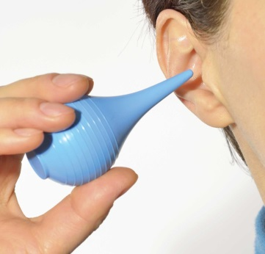
Bulb Syringing:
Instructions for Bulb Syringing: Use olive oil drops twice a day for at least 14 days prior to bulb syringing. Or alternatively use sodium bicarbonate ear drops purchased from your pharmacy (please read the manufacturers leaflet.)
Bulb syringing is a safe, alternate way to remove earwax. Bulb syringes can be easily purchased from a pharmacy and allow you to clear your ears from wax in your own home. If your ears are painful or have fluid coming out of them, or if you have a hole in their ear drum (perforation) or have recently had surgery on your ear you should discuss with doctor or nurse and don’t use this method.
1. Wash your hands.
2. Use a bowl of cooled, boiled water that is warm to the touch, not too hot or too cold
3. Prepare the syringe by squirting water in and out of it a few times.
4. Gently pull your outer ear "up and out" to help straighten out the canal, which will allow better access for the water
5. Tilt your head so the ear to be treated is upmost.
6. Place the tip of the syringe into the opening of the ear.- Do NOT push the syringe further into the ear and gently squirt one or more bulb syringes of water into your ear. (This might be best done in the shower so that the excess water will run into the bathtub and not on your floor)
7. Allow the water to remain in your ear for at least 60 seconds. Gently tilt your head in the opposite direction and wiggle your outer ear
IF AFTER 3 WEEKS THE ABOVE HAS NOT WORKED:
If, after 3 weeks or more, you are still deaf from wax, you may need to make an appointment to discuss referral for micro-suction.

